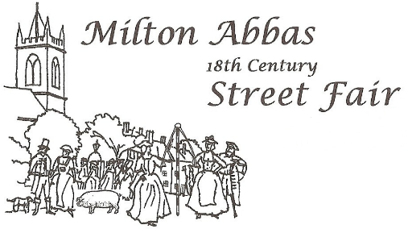
Minutes of the Milton Abbas Street Fair Trustees’ Meeting
held on 22nd April 2026
Present: David French (DF), John Widdowson (JW), Debbie Drammis (DD), Ann Fookes (AF), Jennifer Harrisson (JH), Steve Gould (SG), Karen Mott (KM)

- Welcome

The Trustees were welcomed to the meeting.

- Apologies for Absence

Brian Isherwood (BI) apologised for not being able to attend.

- Minutes of Meeting held on 24th February 2026

The Minutes were agreed and signed by KM as a true record of the meeting.

- Matters Arising

All actions were complete.

- Conflicts of Interest

There were no specific conflicts identified.

- Ratification of Email Decisions

  - The Trustees ratified the decision to award the Play Park funding via the Parish Council Play Park Account.
  - The Trustees agreed with the comment from BI that Trustees could not accept conditions on repayment of the award. JW to write to the Chair of the Hambro Community Initiative requiring repayment without conditions.

Action: JW
  - The Annual report was agreed.

- Financial

DD presented the Annual Financial Return which had been audited and approved. The Trustees approved the Return which was signed by the Secretary (JW).

- Street Fair Trust and Organising Committees

There was further discussion concerning the future of the Street Fair Trust. Karen Mott (KM) has volunteered to be Chair of Trustees. SG suggested that Henri Monier-Willams may be interested in becoming a Trustee and he would provide an email address to the Secretary.

Action: SG.

JW had received emails from Julie Bradshaw and Steve Brewers who would be interested in helping with the organization of the Fair. They would bring the total of the Org Comm to 5 still 2 -4 short of requirement.

It was still the case that no volunteers had been identified to fill the roles of Trustee Treasurer or as Chair and Treasurer of the Organising Committee.

Karen Mott has volunteered to be Chair of the Trustees to be ratified at the AGM.

- Planning for the AGM

The Agenda for the AGM which is to be held at 7:30 pm on the 29th April in the Reading Rooms was agreed.

There was discussion around whether it would be possible to hold a Street Fair in 2027 as proposed on the AGM Agenda. DF suggested that the current members of the Organising Committee hold a precursor meeting to discuss the requirements for a 2027 Street Fair and report on the viability of a Fair in that year. The meeting to be held and report by the end of May for a Trustee decision in June.

The Trustees would recommend to the AGM that a Fair be held in 2027 subject to a satisfactory report from the Org Comm.

JW to email Org Comm members to request a meeting be held.

Action: JW.

- AOB

There was none.

- Date of Next Meeting

The next meeting would be held at 7:30pm on Wednesday 10th June in the church.

