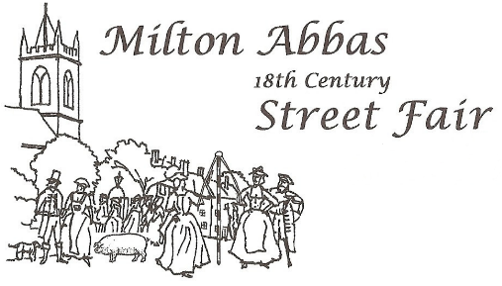
Minutes of the Milton Abbas Street Fair Trustees’ Meeting
held on 24th February 2026
Present: David French (DF), John Widdowson (JW), Debbie Drammis (DD), Ann Fookes (AF), Jennifer Harrisson (JH), Steve Gould (SG), Brian Isherwood (BI), Karen Mott (KM), Mark Castle-Smith (MCS)

- Welcome

The Trustees were welcomed to the meeting. It was Kare Mott’s first meeting as a Trustee.

- Apologies for Absence

There were no apologies.

- Minutes of Meeting held on 14th October 2025

The Minutes were agreed and signed by DF as a true record of the meeting.

- Matters Arising

All actions were complete.

- Conflicts of Interest

There were no specific conflicts identified.

- Ratification of Email Decisions

There were none.

- Financial Position Post Street Fair

DD briefed the Trustees on the latest financial position.

DD said that the bank balance stood at £16,607, including £14,000 Startup and Rainy Day funds. There were still three grants which had yet to be claimed.

JW agreed to chase these and would set a closing date after which the bids would be cancelled.

Action: JW

- Consideration of Potential Bid

The Trustees discussed an email from an individual enquiring whether the Trust would accept a bid to support the provision of massages at a local school. As this appeared to be a bid from a commercial concern the Trustees could not support the bid as it did not meet the requirements of the Trust.

JW will respond informing of this decision.

Action: JW

The Trustees then discussed a previous bid from “The Hambro Arms Community Scheme Steering Committee”. The Trustees had granted £1000 to cover startup costs to secure the future of the village pub. As the pub now has a new landlord these monies should be no longer needed. JW will contact the Steering Committee regarding refunding the money.

JW to draft a letter to the Steering Committee.

Action: JW

- Street Fair Trust and Organising Committees

There was lengthy discussion concerning the future of the Street Fair Trust. The Chair and Treasurer of Trustees will formally resign at the AGM. Also, many members of the Organising Committee, including the Chair and Treasurer have also stepped down. Although three key members of the Committee have agreed to carry on.

MCS made a forceful case, with the message that a Fair could not be run by such a small team. He stated that seven to nine people are required to organize and run the Fair. This was recognized by the Trustees.

Currently, no volunteers had been identified to fill the roles of Trustee Chair and Treasurer or as members of the Organising Committee.

Karen Mott volunteered to be Chair of the Trustees. This is to be ratified at the AGM.

All Trustees were encouraged to seek out potential volunteers. In addition, JW agreed to write an article for the Bulletin and to send the same to Beneficiaries.

Action: JW

JH said that she would produce a poster to encourage villagers to consider becoming a volunteer.

Action: JH
- Planning for the AGM

It was agreed that the AGM would be held at 7:30 pm on the 29th April in the Reading Rooms. It was planned to have a presentation about the Fair to stimulate interest.

It was also agreed that there would be a pre-AGM Trustees meeting on the 21st April in the church.

- AOB

There was none.

- Date of Next Meeting

The next meeting would be held at 7:30pm on the 21st April in the church.

